|  |  |
| --- | --- |
| **DOKUMENTASI EKSTERNAL**  External Documentation |  |
| **[~~TUGAS MANDIRI~~ / PROYEK ]**  **[*Assignment / Project*]** |
| **MATAKULIAH <ISYS6197> – <Business Application Development>**  ***Subject*** |
| SEMESTER [GANJIL/~~GENAP~~/~~PENDEK~~] 2019/2020 ***[Odd/Even/Compact] Semester Year 9999/9999*** |

## Judul Proyek

*[Assignment / Project]**Title*

* **LaVe’s Airline**

## Abstrak [50 – 200 words]

*Abstract*

**LaVe’s Airline** is the national airline of Bluejack. This airline sells flight tickets from and to many countries all over the world. To manage all the transactions, LaVe’s Airline decided to create a program for their admin. You as a programmer, are chosen to develop the program. The program should be made using Java Programming Language.

## Dokumentasi

*Report / Documentation*

* **REPORT / PRINT SCREEN & DESCRIPTION**

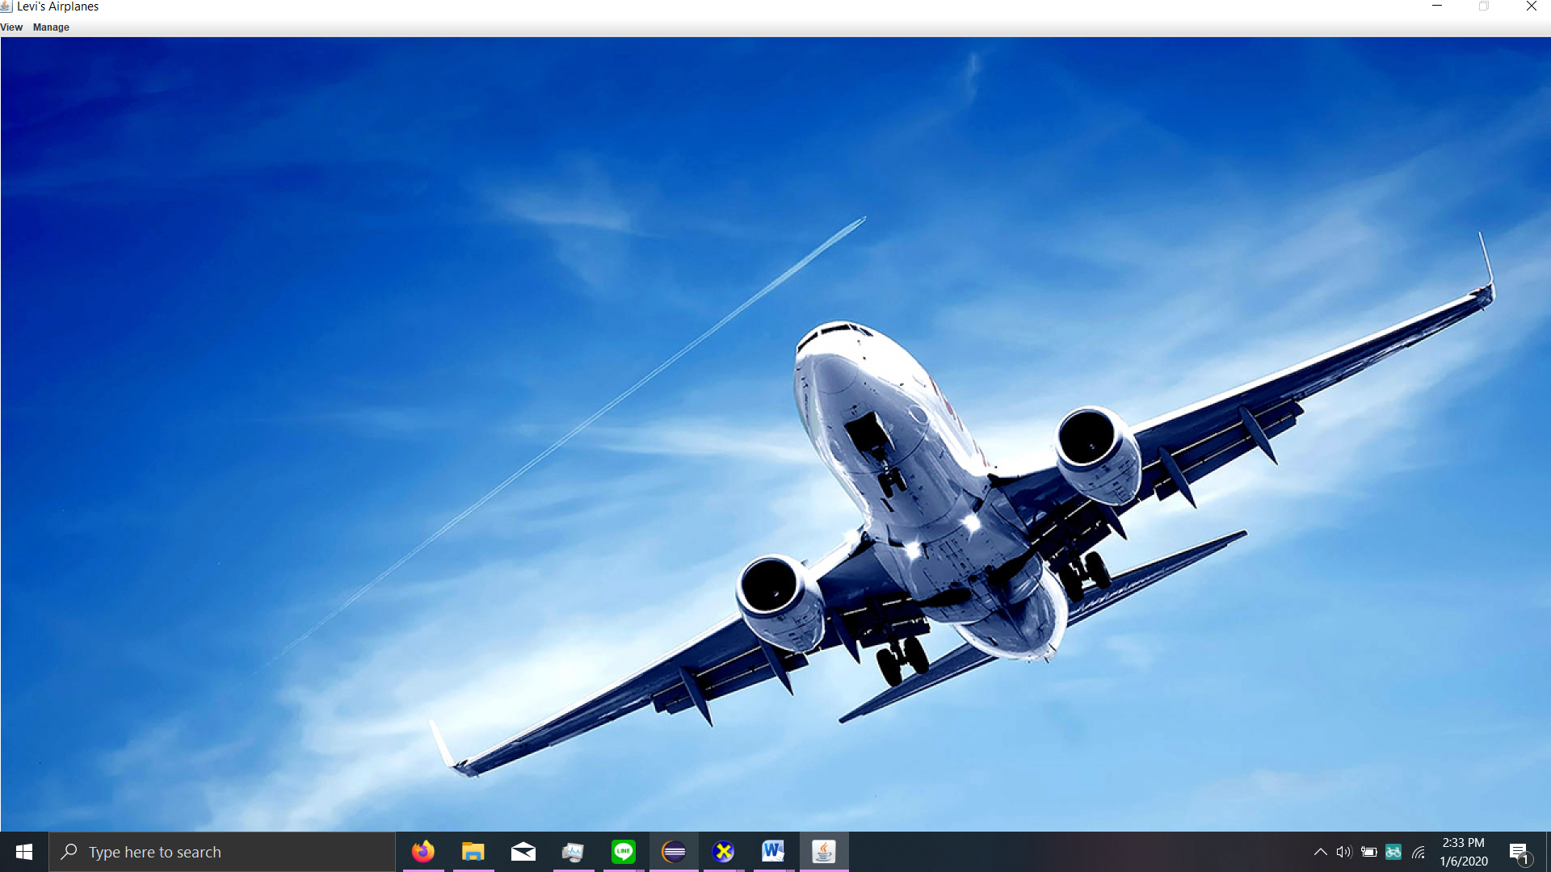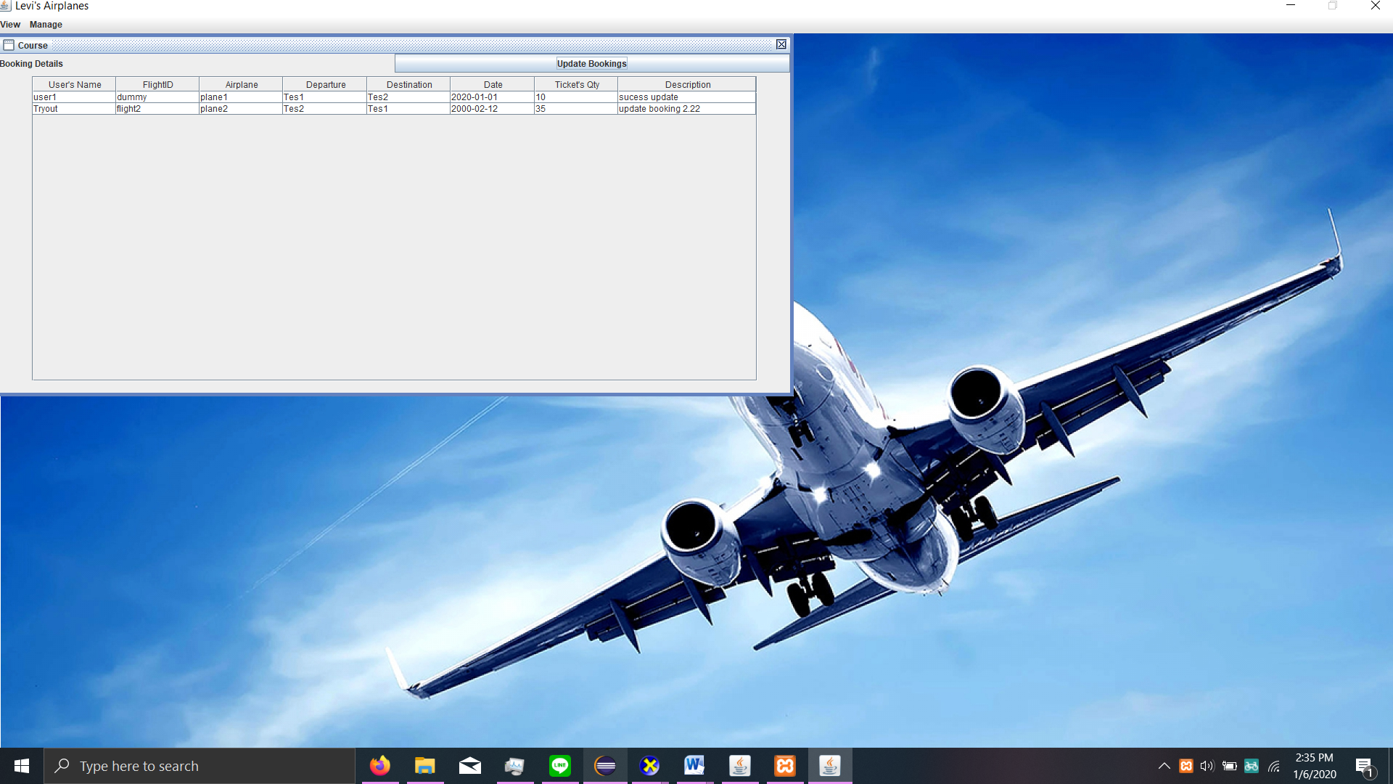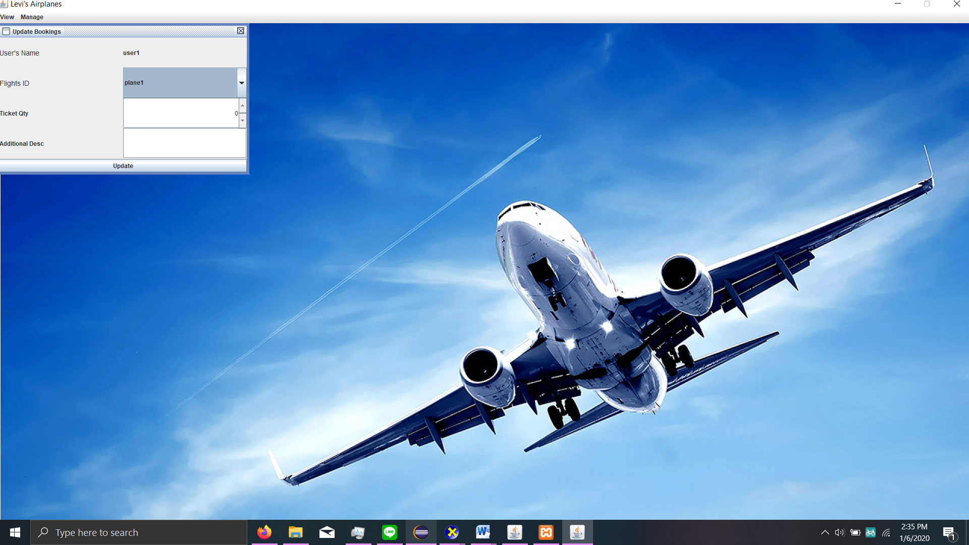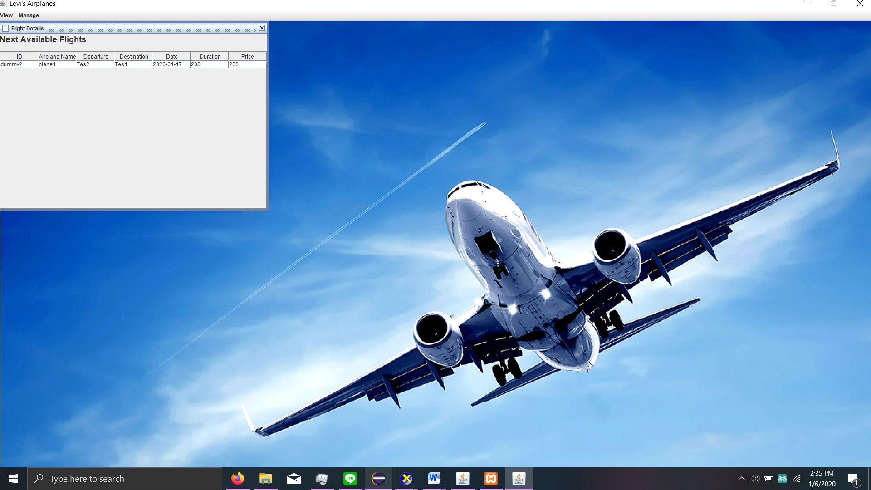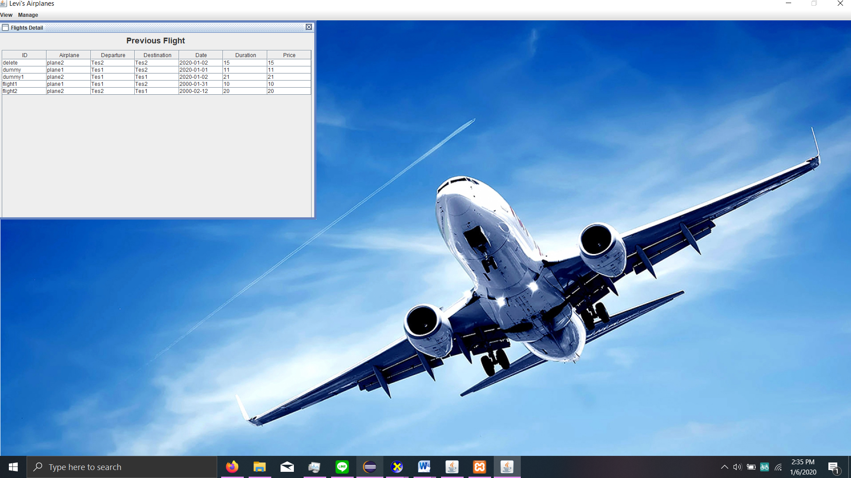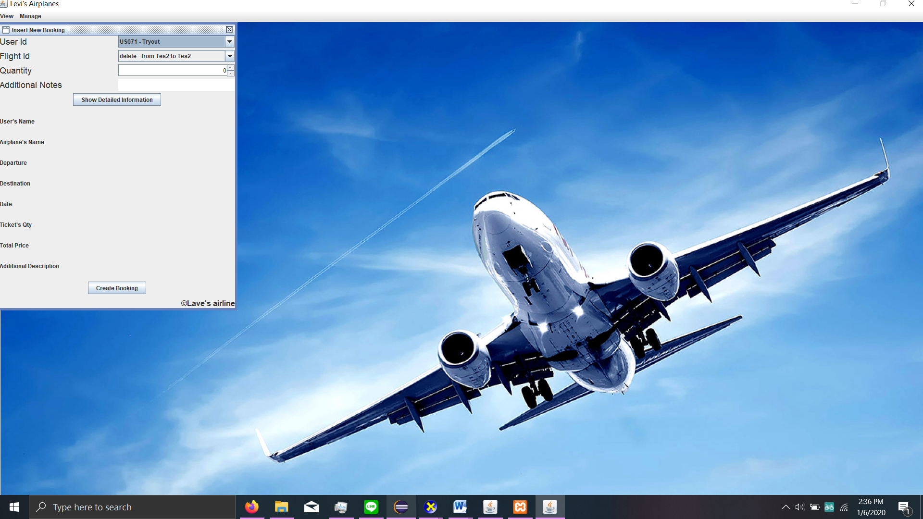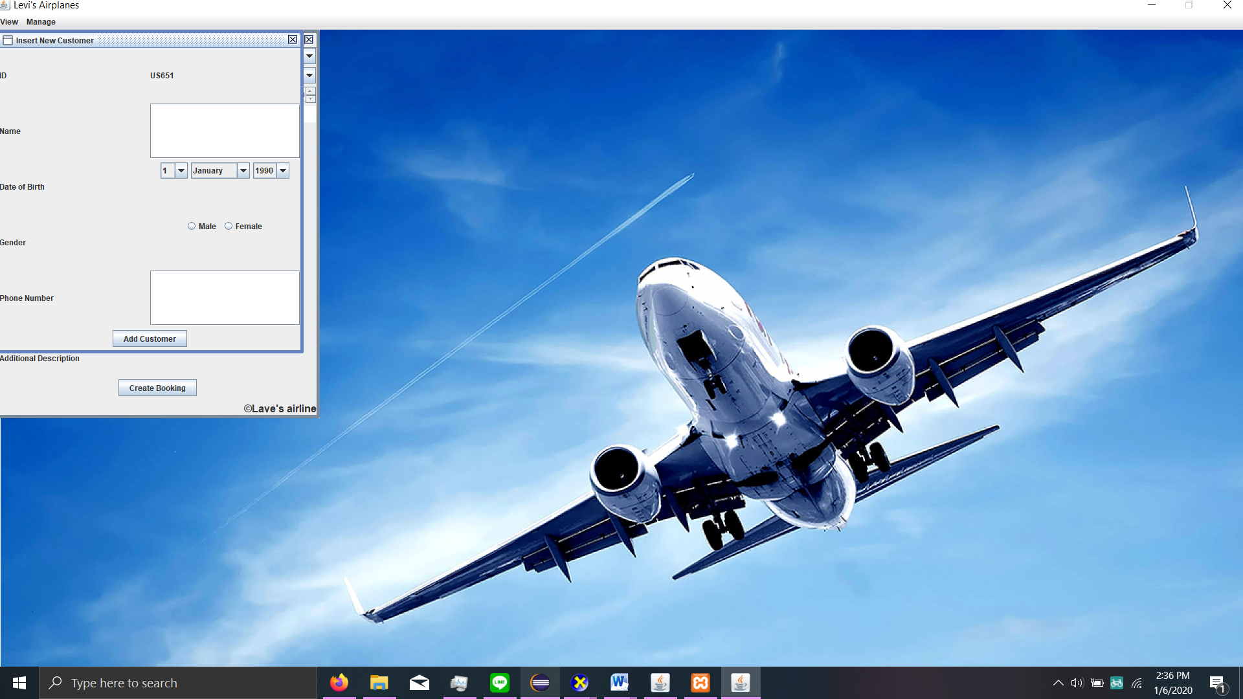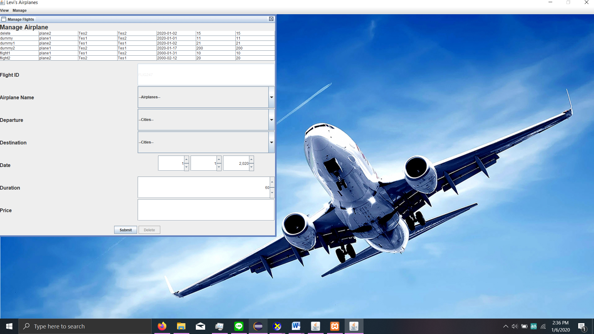

Disiapkan Oleh,

*Prepared by,*

* **<2201728591> - <STEVEN EDRA W>**
* **<2201743895> - <IGNACIO NICOLAS VISHNU>**
* **<2201727960> - <JONATHAN>**
* **<2201731112> - <M ADRIZA FADRULLAH>**